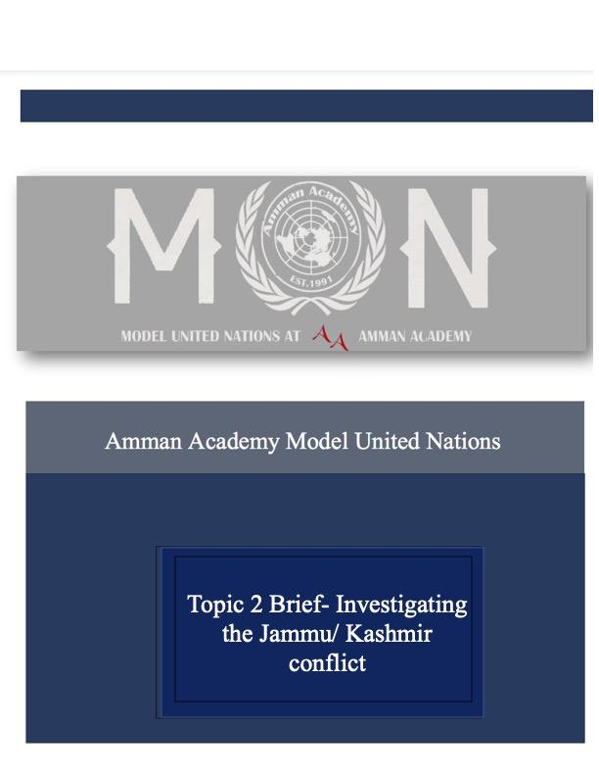

International Institution of Criminal Activity

IICA

Delegate Brief

**President’s Brief:**

Honorable delegates of IICA,

Welcome to the IICA, one of the most impressive, unique, and memorable committees you will ever come across. My name is Tarek Kawar, and I will be your President for AAMUN ‘22. I’m a senior in King’s Academy, and this will be my last chairing experience. I’m happy to know my last will the best.

This committee will be like the film, if you’ve ever seen it, Black Mirror: Bandersnatch. You will have the chance to shape the progression of the committee and change its path. As a crisis committee, IICA is unique, you will never really know what’s coming next. I’m hoping you will enjoy this experience as much as I am anticipating you will because what we have planned out for you all is going to be one of the best experiences you will ever have in an MUN. For that reason, I am so excited to see what you will make out of this rare opportunity.

I can’t wait to see where this committee will go and I’m beyond excited to see where you will take it.

Best,

Tarek Kawar

President of IICA

**Introduction:**

In this year’s AAMUN’22, we are challenging the limits of what a committee could be, what it can do and how much power it beholds over delegates and their actions. Delegates are expected  to keep their delegations private and to themselves until the day of the MUN.

IICA is a committee that holds 14 delegates, half are countries and the other half, cartels/mafias. IICA will be an unfamiliar experience for all, sort of going with the flow as we progress. There will be more room for open debates and flexibility in topics. Alongside more leeway to accuse others and create under the table deals. Delegates will be given a crisis and the delegates will be given time to write directives on the spot and solve it. Only one directive will  be passed per crisis, then we will move on to the next crisis depending on the directive passed and resolution met by the delegates.

Delegates are expected to have their laptops, and chargers, with them all three days of the MUN to be able to work on the directives as mentioned above.

Delegates are expected to come in having read this guide and researched their delegations

**Directives:**

For every crisis that unfolds, you have a limited amount of time to react, get in groups and write clause-like directives. They are the solutions to the problem. You then have limited time to debate and gather a majority vote on one of the directives.

**What is a Directive?**

Directives are clause-like actions. They are passed as a course of action by the committee as a whole. Therefore, they may use all the resources available to the government at that time. In the directive, it must include which resources will be allocated for what and the amount. Some of the information regarding the resources available will be common knowledge within the committee, however, some information will come directly from the president.

They must get a majority vote to pass. We will allow one directive to be passed for each crisis development. We also allow the unlimited amendment of the directive.

During debate, you may address each other openly. You may make accusations. Use personal pronouns. You must only motion to introduce a directive during debate, which the chair sees fit to introduce at that time.

**Definitions:**

1. **Crisis:** A time of intense difficulty or danger, resulting in confusion and/or suffering, in which an instant or quick action must be taken to defuse the situation.
2. **Mafia:** Informal term that is used to describe criminal organizations that bear a strong similarity to the Italian Mafia. The central activity of such an organization would be the arbitration of disputes between criminals as well as the organization and enforcement of illicit agreements between criminals through the use of or threat of violence. Mafias often engage in secondary activities such as gambling, loan sharking, drug-trafficking, prostitution, and fraud. Some of the most known organizations include Triad, The Brotherhood, The commission etc...
3. **Drug Cartel:** A criminal organization that intends on supplying drugs, could range from loose agreements up to formalized commercial deals. Most drug cartels function with a set hierarchy, some of the positions include Falcons, Hitmen, Lieutenants and Drug Lords. (Note: A Drug Cartel usually performs other illegal activities such as money laundry and supply of arms)
4. **Non-state actors:** An individual or group that holds influence, they are completely or partially separate from sovereign states. Can range from business corporations such as multinationals to media agencies and people’s movements.
5. **Boycott:** A ban of relations with other bodies and an end of relations with one of countries, organizations or people in an attempt to protest and weaken the opposite side.
6. **Black market:** Underground economy market where a series of illegal transactions occur in state-controlled areas, usually the transactions are illegal and so are the products being sold or traded. A black market may have negative or positive effects on a state’s economy.
7. **Drug trafficking:** Is the global illegal act of growing, manufacturing, distribution and sale of substances that are prohibited under drug laws. The UNODC continues to monitor the situation and target Drug Cartels.
8. **Money laundry:** The illegal act of concealing the source of money obtained whether legal or illegal money, this could be done through transfers involving foreign banks or other businesses. Laundered money cannot be tracked by governments and are usually used to fund and aid terrorist groups and drug cartels.
9. **UNODC:** The United Nations Office on Drugs and Crime is a UN office that was established in 1997, in an attempt to control drugs and prevent crimes. UNODC functions in three primary manners, research, guidance and support to governments, the office aims at creating treaties and launches campaigns to resolve the issue of drugs. 90% of the office fundings comes from voluntary governments.
10. **Peacekeeper:** Are personnel that monitor and keep peace in post-conflict regions, they remain part of their state’s armed forces but function under the UN’s umbrella. The Security Council usually has control over peacekeeping personnel.
11. **Proxy war:** Is an armed conflict between two or more states which act on the behalf of other parties that are not directly involved. In order for a war to be considered as proxy there must be a long-term relationship between external actors and the involved party, the relationship is usually in the form of funding or arms.
12. **Conventional** **Weapons:** the weapons not of mass destruction, can include fighting vehicles aircrafts warships and small arms.
13. **Weapons of mass destruction:** ones of nuclear biological and chemical weaponry. The acceptance of usage of conventional weapons during war is governed by the geneva conventions

**Keep in mind:**

1. **Colombian Drug conflict:**

Colombian government’s attempts to reduce crime is one of the main origins of the Colombian conflict. A number of drug cartels and guerrillas are fighting each other and the Colombian government to increase their influence on the region. This conflict resulted in total unrest in Colombia and the loose supply and distribution of drugs all over the Americas.

*Relevant links:*

*https://www.youtube.com/watch?v=NDa_SpvbeCQ https://www.crisisgroup.org/latin-america-caribbean/andes/colombia/war-and-drugs- colombia* [*https://www.vox.com/2016/5/8/18089368/war-on-drugs-marijuana-cocaine-heroin-meth*](https://www.vox.com/2016/5/8/18089368/war-on-drugs-marijuana-cocaine-heroin-meth)

[*https://www.cfr.org/backgrounder/mexicos-long-war-drugs-crime-and-cartels*](https://www.cfr.org/backgrounder/mexicos-long-war-drugs-crime-and-cartels)

1. **The Russia and Ukraine conflict:**

The war between Russia and Ukraine began in early 2014, when Russia occupied Crimea (an area in Ukraine that is primarily populated by people of Russian origin) during February through March of that year. 2014 saw a rise in political strains, cyberattacks, and naval incidents in the conflict. Tensions increased throughout 2021 as a result of a Russian military buildup close to the Ukrainian border, and on February 24, 2022, Russia began a full-scale invasion of Ukraine. The invasion began in the eastern Ukrainian territory of Donbas. In addition to declaring martial law, Zelenskyy formally severed diplomatic ties with Russia.

*Relevant links:*

[*https://www.europarl.europa.eu/EPRS/TD_Russia_war_Ukraine.pdf*](https://www.europarl.europa.eu/EPRS/TD_Russia_war_Ukraine.pdf)

[*https://www.cfr.org/backgrounder/ukraine-conflict-crossroads-europe-and-russia*](https://www.cfr.org/backgrounder/ukraine-conflict-crossroads-europe-and-russia)

[*https://www.youtube.com/watch?v=Y9nFUQlw5Ro*](https://www.youtube.com/watch?v=Y9nFUQlw5Ro)

[*http://www.jstor.org/stable/24483306*](http://www.jstor.org/stable/24483306)

1. **Heroin, opiate and narcotic trade in the Western Balkans and the passage of drugs through the Balkan trade route**

A new report on cocaine use conducted by Europol and the United Nations Office on Drugs and Crime (UNODC), has revealed exactly how much power  criminal organizations possess along the Balkan trade route. With the majority of the world's cocaine coming from Central and South American countries, particularly Colombia, transporting it to Europe has become a profitable business enterprise that Albanian-speaking and Western Balkans criminal networks have been aggressively pursuing. These Western Balkan organizations have become so numerous that they are now challenging the dominance of well-established European drug networks such as the Italian 'Ndrangheta. In fact, the overall worth of illicit heroin and opium smuggled from Afghanistan to Western Europe via the Balkans is estimated to be around $28 billion per year. Western and Central Europe generates 65 percent of this total ($18 billion). The four main European heroin markets – France, the United Kingdom, Germany, and Italy – account for approximately half of the gross revenues, as the majority of heroin profits are produced on retail markets.

***Relevant links:***

[*Changes at the drugs market in the Western Balkans - Drug Policy Network SEE (dpnsee.org)*](http://dpnsee.org/2021/06/21/changes-at-the-drugs-market-in-the-western-balkans/)

[*How Western Balkans organised crime makes Europe's cocaine trade possible (emerging-europe.com)*](https://emerging-europe.com/news/how-western-balkans-organised-crime-makes-europes-cocaine-trade-possible/)

[*Light on the Balkan drug routes (esisc.org)*](http://www.esisc.org/publications/briefings/light-on-the-balkan-drug-routes)